Assignment #1

Group Members:
- Muhammad Aun Anis (24P-3017)
- Sohaib Ahmed (24P-3010)

Course: Programming Fundamentals

Course Code: CS1002

Program: Software Engineering (SE)

Semester: 1st

Date: 21/08/2024

HISTORY OF
COMPUTER LANGUAGES
(By Sohaib Ahmed & M. Aun Anis)

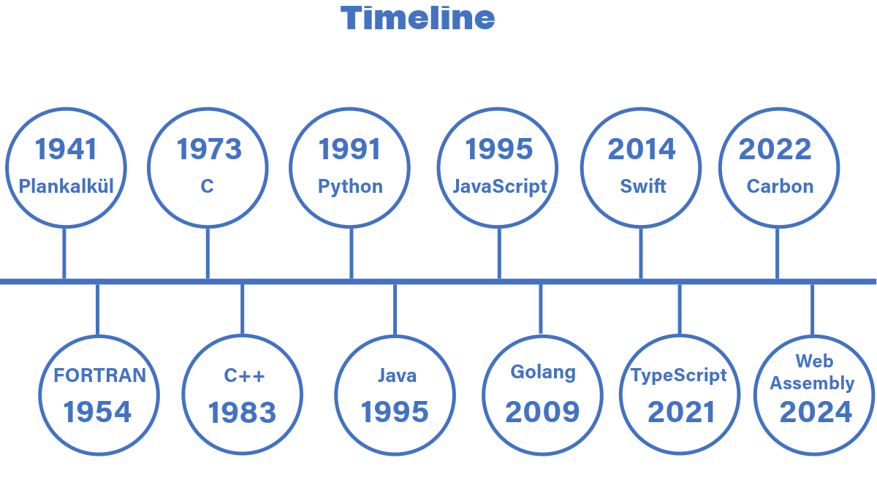
The evolution of programming languages showcases a vibrant path of creativity and adjustment, stretching across more than a hundred years of technological progress. It all started with foundational computing ideas and the creation of machine code, which required programming directly in binary format. Early programming languages were highly obscure, relying on mathematical notation plus perplexing syntax.
In the 1940s, when the first electrically powered computers were invented the limitations of the machines such as low speed and memory capacity only allowed programmers to write code in hand tuned assembly languages until, eventually it was realized that programming in assembly languages was very inconvenient as it required a great deal of effort, both intellectually and physically.
Hence the first high level programming language Plankalkül, was created by Konrad Zuse between 1942 and 1945. Similarly, the first functioning programming languages which was designed to convey sets of instructions to an electronic computer were written in the early 1950s.
Short Code created by John Mauchly was one of the first high level programming languages designed for electronic computers. Though it was quite certainly an upgrade as it represented mathematical expressions in understandable form, the program had to be translated into machine code every time it was executed which resulted in a much slower overall process in comparison to just running the equivalent machine code.
In the early 1950s, Alick Glennie developed Autocode, widely regarded as the first compiled programming language. Further iterations of the language were also published which were made for specific computers (Mark 1, Ferranti Mercury).
In 1954, FORTRAN was invented by a team led by John Backus at IBM and was the first popular high-level general purpose language to have a functional use. At first it was met with much skepticism due to many bugs and delays in development but even today it is a widely used language for high-performance computing and, is also used for programs that benchmark and rank the world’s TOP500 fastest computers.
Other early programming languages some of which are still used to date include, LISP and ALGOL 60 which was particularly influential in the design of later more modern languages.
The period 1960s to 1980s brought a lot of advancement in the world of programming languages, with one of the most noticeable inventions being that of C, by Dennis Ritchie and Ken Thompson between 1969 and 1973. In the 1980s, C with classes (later renamed to C++) combined object oriented and systems programming.
A major historic event occurred in the mid 1990s with the rapid growth of the internet. This caused a surge in the development of programming languages. Specifically, JavaScript rose to popularity because of its integration with Netscape Navigator (web browser). In this period a big slogan of the programming world was programmer productivity. Many Rapid Application Development (RAD) languages also emerged such as Visual Basic and Java.
Languages more convenient and innovative than the RAD languages emerged called scripting languages. They featured new syntaxes and offered more opportune designs. Some newer programming languages included other languages in their distribution to save development time. These included the likes of Python and Ruby which included Tcl to support GUI programming.
Recent times has also witnessed a fair share of development in the domain of programming languages. Support for functional programming has been increased in mainstream languages that are widely used commercially. A growth in interest for visual programming languages such as Scratch (developed by MIT), LabVIEW and PWCT has been seen.
A new philosophy of “Open Source” has been adapted in the development of newer languages such as PHP, Python, Scala and the GNU Compiler Collection.
Multi billion-dollar companies introduced their own programming languages in recent years. Microsoft introduced C#, F#, Typescript and more. Google introduced Go, Dart, Carbon. Apple introduced Swift while Meta introduced Hack. These languages reflect the companies' efforts to create tailored solutions that address specific needs, optimize performance, and improve development practices within their respective technology environments.
Looking back at the history of programming languages shows a steady progress toward making coding easier, more flexible, and more powerful. We started with basic machine code and assembly languages, which were complex and difficult to work with. Over time, we developed higher-level languages that are easier to use and understand. Each new language has improved on the previous ones, solving problems and making programming more efficient. This constant change reflects broader technological advances and helps shape the future of software development. As technology keeps advancing, programming languages will keep evolving, allowing us to do even more with computers and software.
The realm of Computer Science is always rapidly developing and mankind has only yet explored a small portion of it. It is safe to say that when it comes to the subject of Programming in general, the possibilities are endless.

-------------------------------------------------------------------------------------------------------------

